**Disordered Photonics: Anderson localization in Penrose lattices - Quasicrystals**

Anderson localization

The propagation of waves in periodic and disordered structures is at the foundation of modern condensed-matter physics. Anderson localization is a key concept, formulated to explain the spatial confinement due to disorder of quantum mechanical wave functions that would spread

over the entire system in an ideal periodic lattice.

Periodic Lattices

1. *One-dimensional periodic lattices (1D)*: one example is lattice of coupled optical waveguides patterned on an AlGaAs substrate.
2. *Quasi-periodic lattices (1D-quasi):* one example is a 1D tight-binding periodic lattice with on-site modulation λ, such that the ratio between the modulation and the lattice period is χ. Localization (sharp) there can be described by AA model (Aubry-Andre).
3. *Two dimensional lattices (2D)*: photonic quasicrystals the time evolution of waves inside the lattice is combined with propagation in another spatial dimension. It is possible to directly image the propagated wave function inside the lattice, in contrast to traditional transmission or conductance measurements.

Sharp localization:

For a certain class of quasiperiodic potentials, a localization phase transition can occur already in one dimension. Below the transition all the modes of the system are extended and therefore an initially narrow wave packet eventually spreads across the entire lattice. Above the critical point λc/C, all modes are localized and expansion is suppressed.

Time evolution: describing light dynamics in these structures are identical to the equations describing the time evolution of a single electron in a lattice under the tight binding approximation (γ=Kerr coefficient, introduces nonlinearity):



Disorder: introduced to the lattice by randomly changing the width of each waveguide in a finite range W +-δ where W is the mean value (typically 4 μm in our samples).

* In disordered systems, a localization phase transition is expected to occur in three dimensions as the strength of disorder crosses a critical value.
* *(1D)*:
  + βn become random in the range β0 +- Δ:
  + By keeping the lattice periodic on average the parameters Cn become independent of n to a very good approximation, meeting the conditions assumed by Anderson
  + A measure of disorder is then given by the ratio Δ/C. As it is increased, a larger fraction of the modes becomes localized within the finite lattice.
* *(1D-quasi):* Comparison between Anderson’s and Aubry and Andre (AA):
  + Anderson’s:  
    
    - For infinite one-dimensional lattices, all eigenmodes are localized. In a finite size system of length L and weak enough disorder, the eigenstates appear to be extended (not localized) since their localization length is larger than the system size.
    - No sharp localization transition at nonzero λ, instead there is a smooth decrease of the localization length as the strength of the disorder λ is increased.
    - As disorder increases, the eigenmodes become localized within the finite lattice, but this cannot be considered as a phase transition since the amount of disorder needed to observe localization goes to zero as the system’s size goes to infinity
  + Aubry and Andre:  
    
    - For a finite size system of length L, the requirement to be incommensurate is that no commensurate frequencies havingmore than one period within L would be less than 1/L apart from the incommensurate frequency ratio
    - A sharp localization phase transition takes place at a modulation strength λ=2C. If the incommensurability condition described above is not met, the system does not exhibit a sharp localization transition.
    - All eigenmodes are extended below the transition and become localized simultaneously above λ=2C, with a typical width smaller than the size of the system.

1D periodic lattice Anderson localization

**First way**

We are injecting a wide beam (covering several lattice sites) at different locations across the lattice. At specific locations, wave expansion is suppressed and prominent localization is evident. In these cases, the input beam overlap significantly with a single localized eigenmode of the lattice, while the overlap with the other modes of the lattice is eliminated.

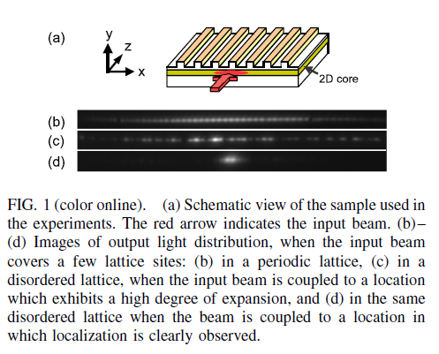

1. Calculated eigenmodes and eigenvalues of the weakly disordered lattice used in the experiments. The band of eigenvalues deviates slightly from the cosine-shaped band of a periodic lattice. Localized modes are formed, associated with eigenvalues near the edges of the band (insets 1,2), while modes near the band center remain extended (inset 3). Modes near the edges of the spectrum become localized first.  
   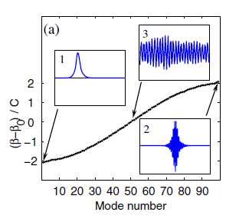
2. Measurements of pure **flat-phase** Anderson localized modes. Panels show a comparison between measurements (blue) and the corresponding calculated **eigenmodes** of the lattice (red).
3. Same for **staggered** localized eigenmodes. In all cases no fitting procedures are used.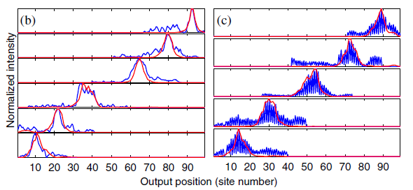

* Localized eigenmodes near the bottom of the band are **flat phased**; i.e., their wave functions amplitude is in phase at all sites (see inset 1), while the localized eigenmodes at the top of the band are **staggered**; i.e., their wave function’s amplitude has a π phase flip between adjacent sites (inset 2).
* To excite the **staggered modes** associated with the top of the band, the input beam was tilted with respect to the lattice to induce a π phase difference in the excitation of adjacent waveguides
* These results demonstrate the ability to excite pure Anderson localized eigenmodes.

Nonlinear perturbations on localized eigenmodes is studied by exciting a pure localized mode and increasing the input beam power-> weak nonlinear regime

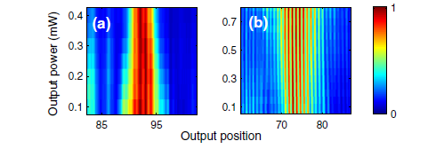

Weak positive nonlinearity tends to further localize flat phased localized modes, but tends to delocalize staggered modes. Non-linearity shifts of a localized eigenmode’s frequency (represented here by the parameter β) can lead to delocalization if the frequency crosses a resonance with other modes of the lattice.

* Non linearity shifts **staggered** modes from the edge of the band into the linear spectrum.
* Conversely, the **flat** phased modes at the other edge of the band are shifted by nonlinearity out of the linear spectrum; thus, they remain localized.

**Second way**

We are injecting light into a single lattice site, thus exciting a tight δ-like wave packet of all eigenmodes having non-vanishing overlap with the excited site.

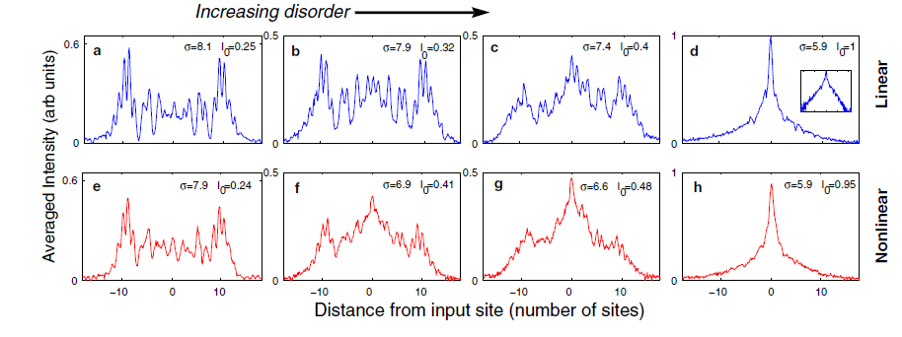

* Without disorder, single site excitation results in ballistic propagation (wave packet width grows linearly with time)-> two separated lobes
* At high disorder a highly localized, exponentially decaying distribution is observed-> Anderson localization
* Measurements of the same lattices in the nonlinear case show that on average nonlinearity tends to increase localization for intermediate disorder levels. The buildup of the localized component and the suppression of the ballistic component happen faster under nonlinear conditions. This description holds for short time scales in which the ballistic component is still present. On much longer time scales, sub-diffusive delocalization due to nonlinearity was predicted to take over.
* It is known that for infinite disordered 1D systems and for long time scales, wave packet expansion is always fully suppressed. However, on short time scales, wave packets do evolve. Localization emerges from ballistic expansion through the continuous buildup of a localized component and the suppression of a ballistic component.
* In the 1D case the diffusive dynamics is absent. In quasi-1D experiments the expansion turns quickly from ballistic to diffusive and becomes localized after much longer propagation times.

1D-quasi periodic lattice

Here we measure wave packet expansion to observe the signature of the localization transition in quasiperiodic lattices. In the experiment we use a one-dimensional photonic lattice of evanescently coupled waveguides.

* Below the transition all the modes of the system are extended and therefore an initially narrow wave packet eventually spreads across the entire lattice. Above the critical point (here λ/C=2), all modes are localized and expansion is suppressed.

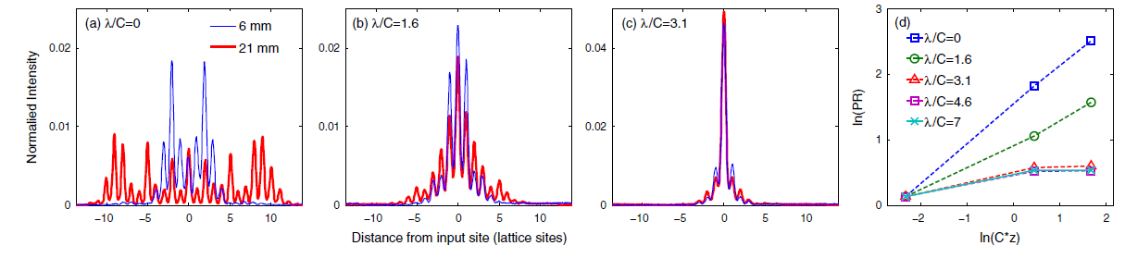

* Weak Nonlinear interactions below and above the transition:

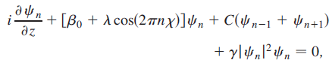

* + For λ=0, nonlinear effects result in a reduced expansion of the wave packet, because the sign of the nonlinearity in our system corresponds to self-focusing interaction.
  + In the localized regime (λ/C>2), nonlinear effects result in a slight increase in the width of the localized wave packets

